M400 Pinpad Install and Setup Guide

## Equipment List:

* Power cable
* Verifone Module - (USB-C)
* Verifone - M400 Pin Pad
* Stylus

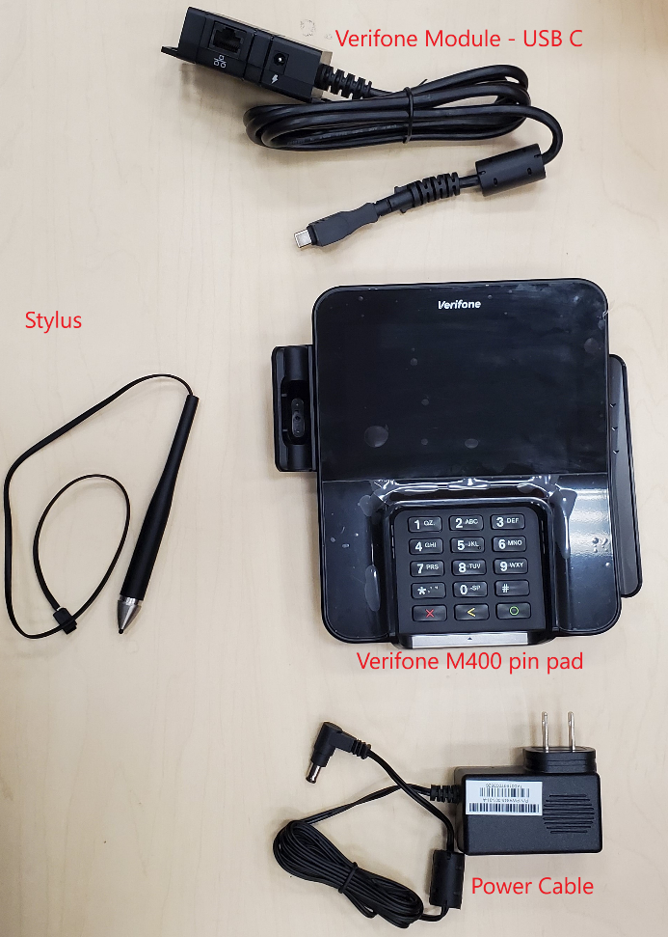

## Connecting the stylus

* If the stylus is not connected, remove the black clip that holds the stylus on the left side of the pinpad (will be on your right if you are looking at the back of the pinpad) by pressing in the black retaining clip on the back side of it.
* The stylus has a small black part that slides down where its circled.
* 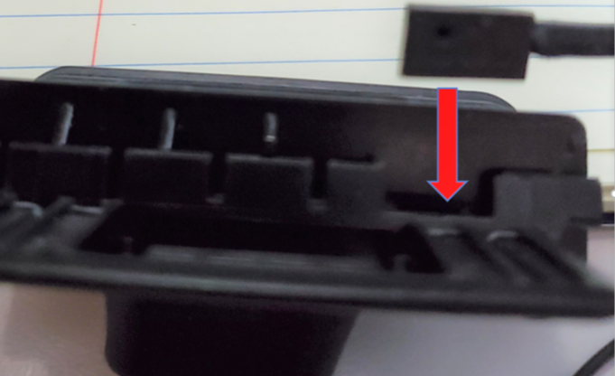Once that is in place the black clip should slide back into the pin pad.

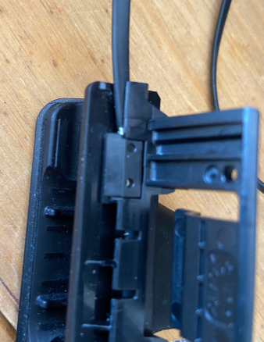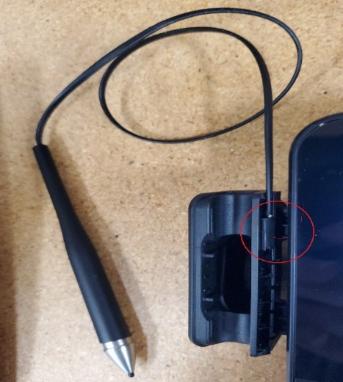

## Installing Verifone M400 Pin Pad:

1. Verify with the Store manager that all components are on site.
2. Add serial number to Payware connect. Via “Account Admin” then “Device Manager”

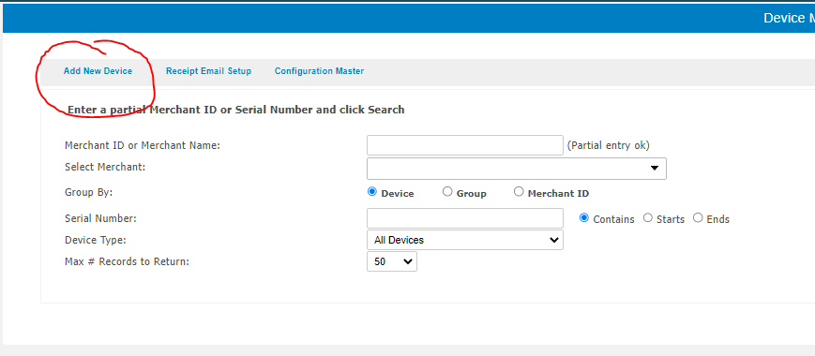

sys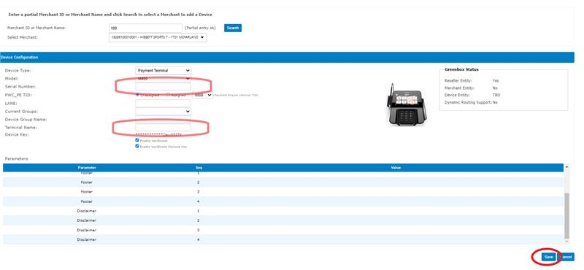

1. Start with removing the panel on the back on the M400 pin pad by sliding it up.

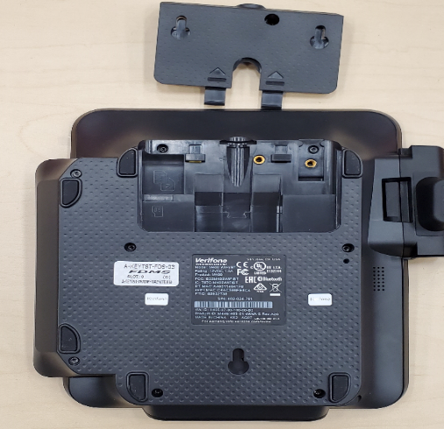

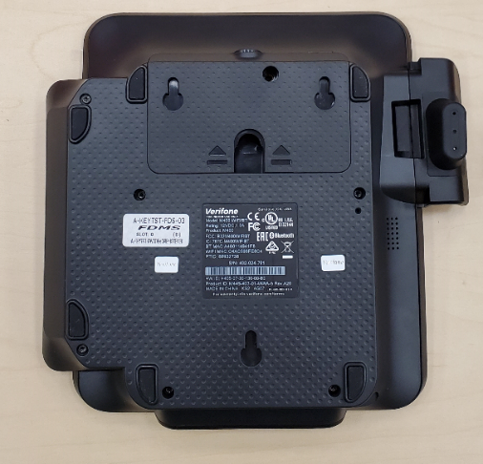

1. 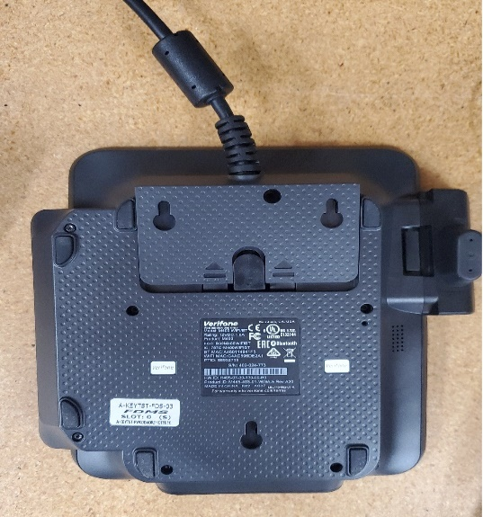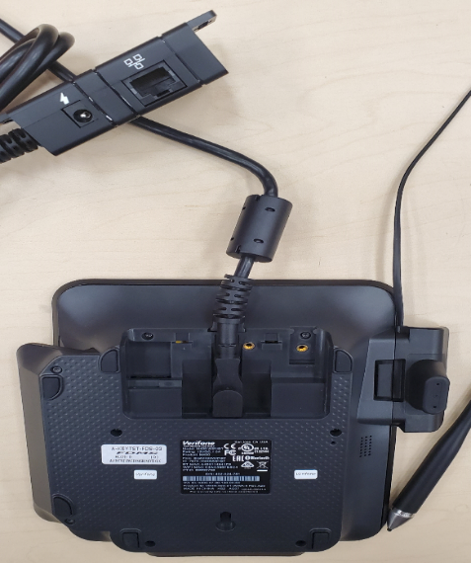Take the Module cable and plug the USB-C end into the port that.
2. Make sure the cable is pushed in tight and slide the panel back down to hold/lock the cable in place.
3. Install the device back on the VeriFone stand.( If applicable/Set on counter top)
4. Connect the power cable to the port on the VeriFone Module Box that has the power log.
5. 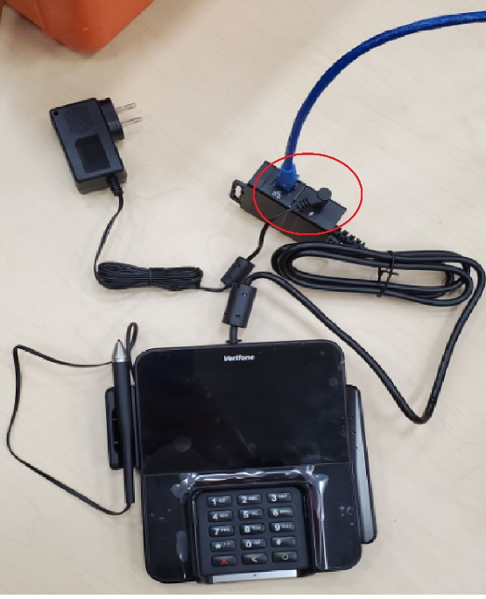Connect the Ethernet cable to the other port on the VeriFone Module, the Ethernet port.
6. Once the power cable and ethernet has been connected the M400 should start booting up.

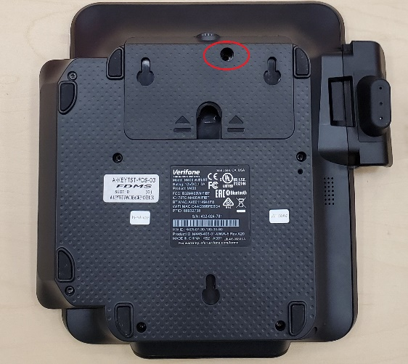**Note:**  
If Available: One Small screw goes in the back to fasten the panel/cable in place.

## Rebooting M400 Verifone Pin Pad

* To get to the “Power Panel” screen to reboot the M400 Pin pad:
  + Press and hold the Cancel key until the Power Panel screen comes up (after 5 - 20 seconds).

Or

* + Press **1, 5, 9** all at once – Click the *“Control Panel”* -> “Power Panel”.
* This Power Panel screen should have a *“Reboot”* option.
* If that does not work disconnect the terminal from the power supply.

**Pairing / Setup Start:**

## Network Configuration: DHCP (Primary)

* Press **1, 5, 9** all at once. Click the *“****Control Panel****”* then click the “**Sysmode**” option to get to the Admin Screen.
* A prompt for the supervisor password will show.
* 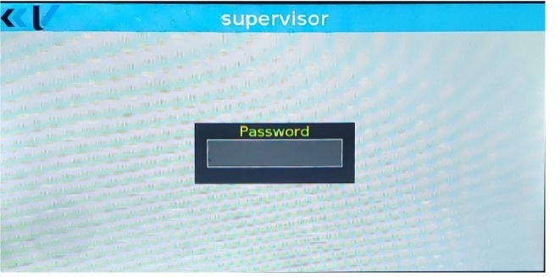Enter the password and press the confirm button.   
  Password: **1668321**
* Click the following options to get to the network settings:

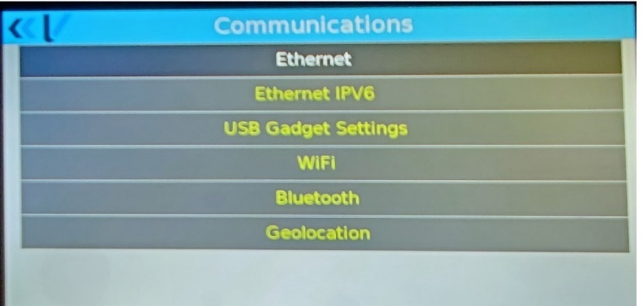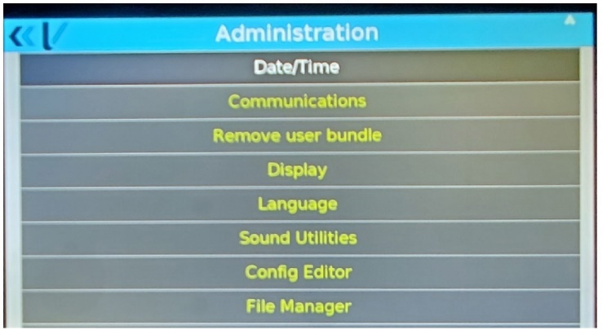***Administration -> Communications -> Ethernet -> eth0***

* 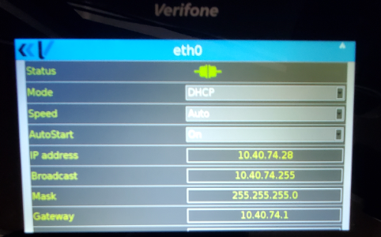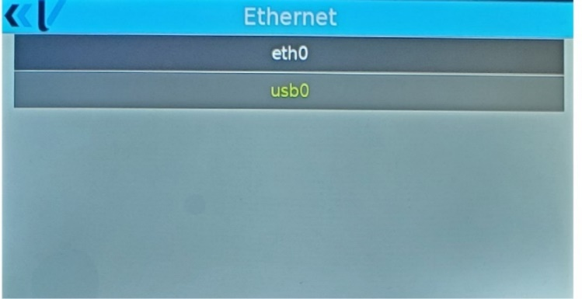The **eth0** screen is the one where the network/IP settings are set.

1. Select DHCP from the “Mode” Option 10.2.10.26
2. Press the back arrow at the top left of the pinpad.

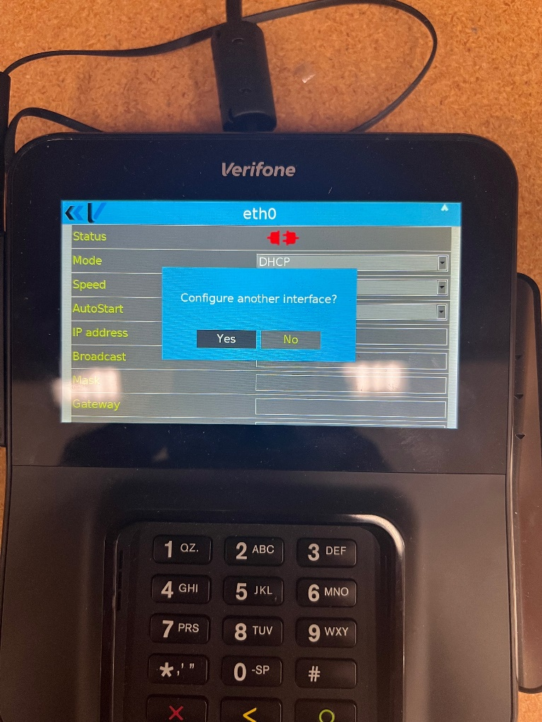

1. Press “Yes” when it asks you to “Do you want to Save your Changes?”
2. Press “No” when it asks you “Do you want to configure another interface” press “No”

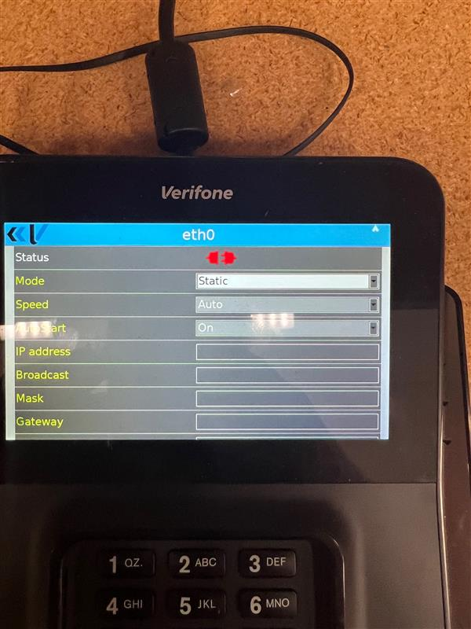 

1. 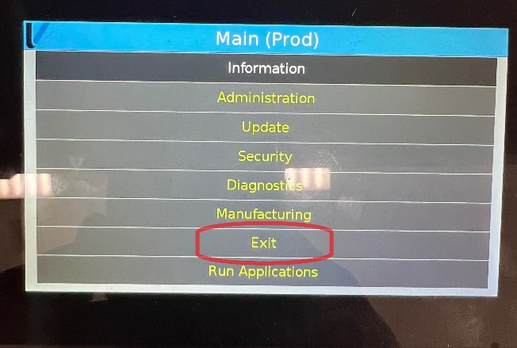Press the back Button/red button until you see the “Exit” option.
2. Press “Exit” Then press “reboot”

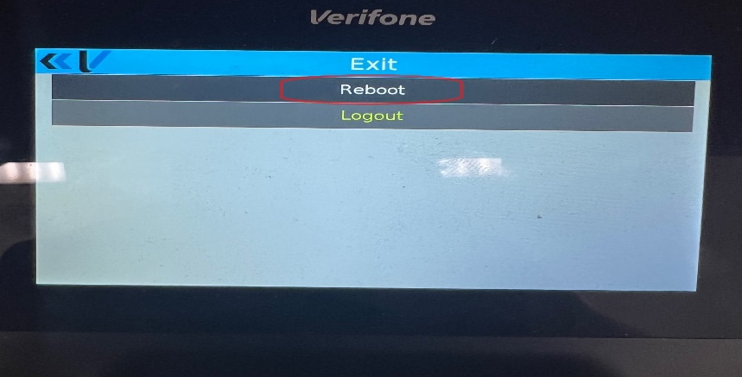

1. While the pinpad reboots have the Store manager watch the pinpad screen until the device shows the “Determining IP Connection Status” screen. At this point, the pinpad should give you the IP address that was selected via DHCP.
2. BE SURE TO KEEP TRACK OF THIS IP. IT WILL BE NEED TO BE ADDED TO THE XSTORE PROPERTIES FILE TO PAIR.

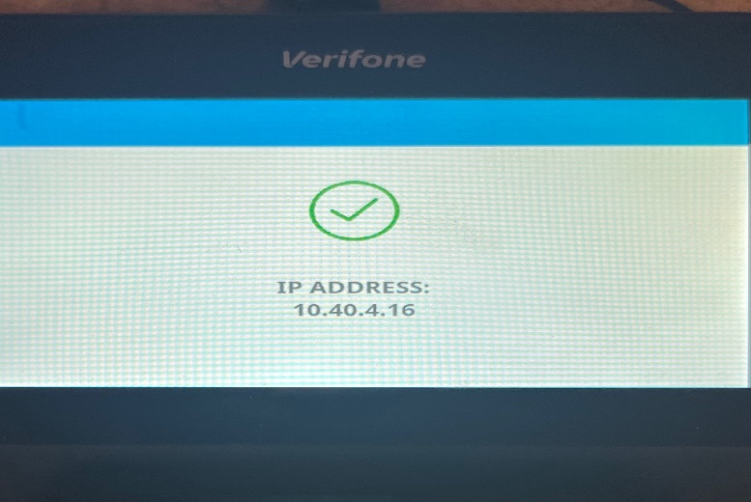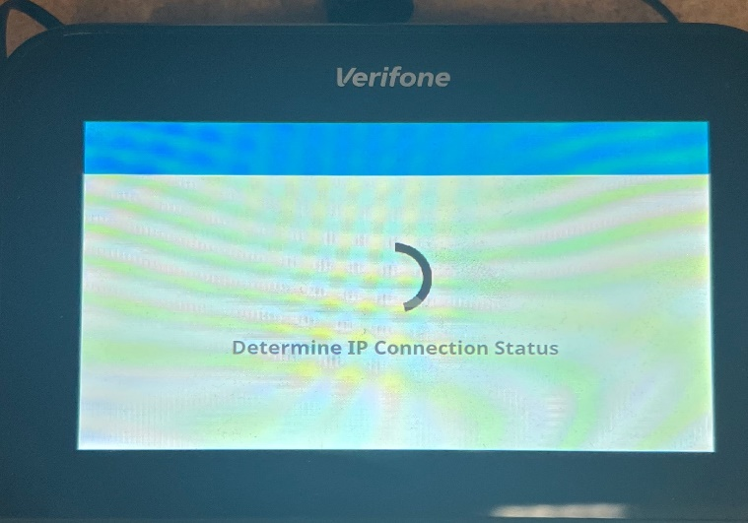

## 

## (Optional) Setting Static IP for Pin Pad

Use this method if issues occur with the pinpad pulling an undesired IP address via DHCP

After the terminal is powered on, follow the steps to setup static IP settings.

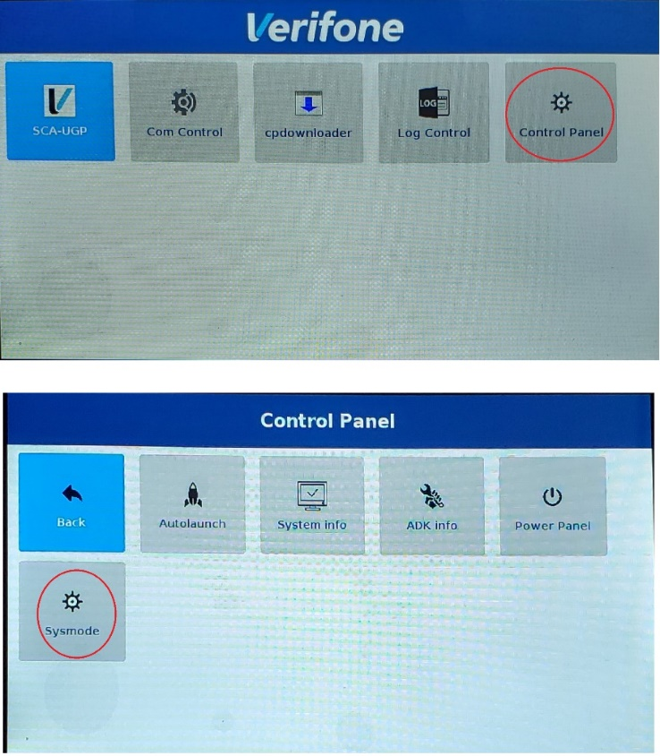

* Press **1, 5, 9** all at once. Click the *“****Control Panel****”* then click the “**Sysmode**” option to get to the Admin Screen.
* A prompt for the supervisor password will show.
* Enter the password and press the confirm button.   
  Password: **1668321**

* Click the following options to get to the network settings:

***Administration -> Communications -> Ethernet -> eth0***

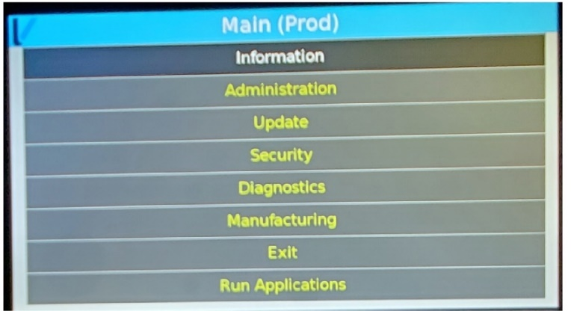

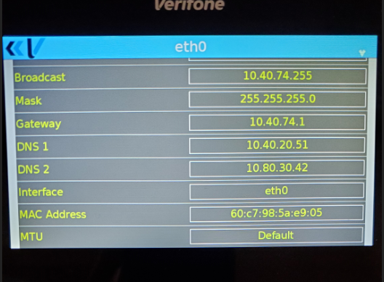

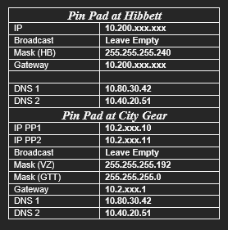The **eth0** screen is the one where the network/IP settings are set

* Select the **Mode** option that says ***DHCP***and change that to ***Static***.
* Click in the IP Address area and enter in the wanted IP address and gateway previously written

down, along with the settings below for Mask and DNS addresses.

* After those are entered push the back arrow in the top left corner and press save.
* Configure another interface: **Click No**
* Exit à Reboot

# Store Register Steps and Additional Setup Info

This section has all information to be used during the register setup process as well as the addistion cleanup.

Verify Pinpad is Online on Expected IP 10

XStore Property file changes 11

Starting XStore and Pairing the Pinpad 13

Check each new pinpad in Payware 13

Manually Remove Device Key 15

Check Device Hierarchy in VHQ 15

Verify Downloads Processed In VHQ 15

Request Heartbeat 17

Cleanup Work 17

### XStore Property file changes - IMPORTANT

These are the settings that need to be updated for the pinpad to be recognized by Xstore (the POS system), these need to be edited in the Xstore.properties file.

Path for the xstore.properties file is \\hibxst****r01\c$\xstore\updates\ (You can copy this and put it into a file explorer, just change the asterisks to the 4 digit store number, and the 1 to whichever register you are working on.

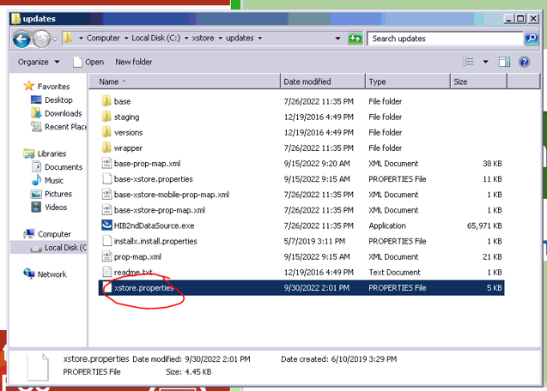

**Enter your DHCP IP address that you got from the Pinpad here:**

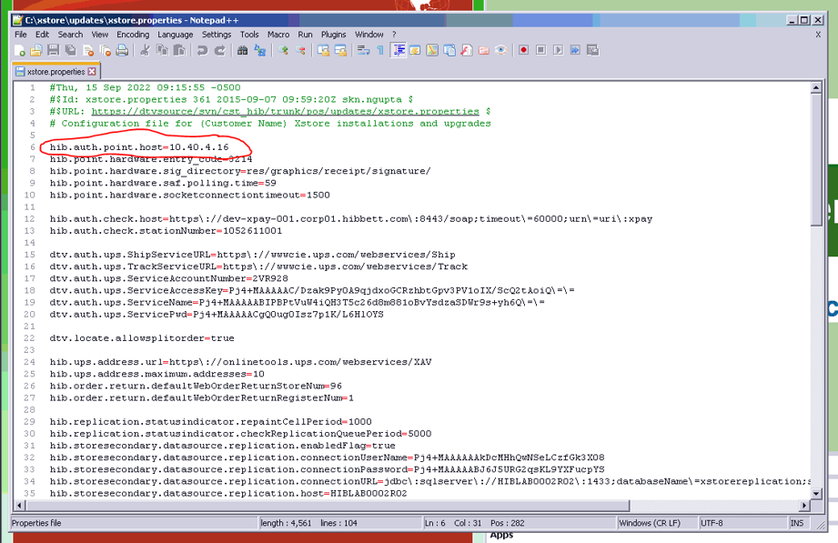

* **Below are the Setting for the M400 pinpad in the xstore properties file. These should already be complete and should not need adjustment. This is just here for reference.**

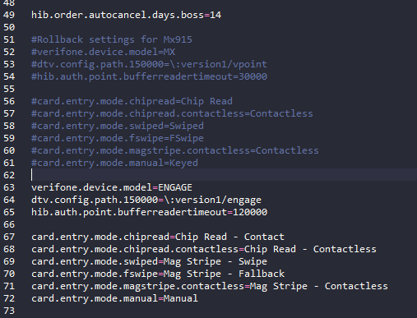**Settings for M400:**

verifone.device.model=ENGAGE

dtv.config.path.150000=\:version1/engage

hib.auth.point.bufferreadertimeout=210000

card.entry.mode.chipread=Chip Read - Contact

card.entry.mode.chipread.contactless=Chip Read - Contactless

card.entry.mode.swiped=Mag Stripe - Swipe

card.entry.mode.fswipe=Mag Stripe - Fallback

card.entry.mode.magstripe.contactless=Mag Stripe - Contactless

card.entry.mode.manual=Manual

klarna.validation.promp.enable=true

* **AFTER UPDATING this FILE, YOU ALWAYS MUST DO THE FOLLOWING STEP!!!!**
* Remote into the register, stop Xstore (You can use Clint’s App to do this, but some registers also have a StopXStore.bat in the C:\Xstore folder, if you can’t do either of those, or if it’s just more convenient, you can navigate to C:\Xstore\tmp and delete all files with a “.anchor” extension)

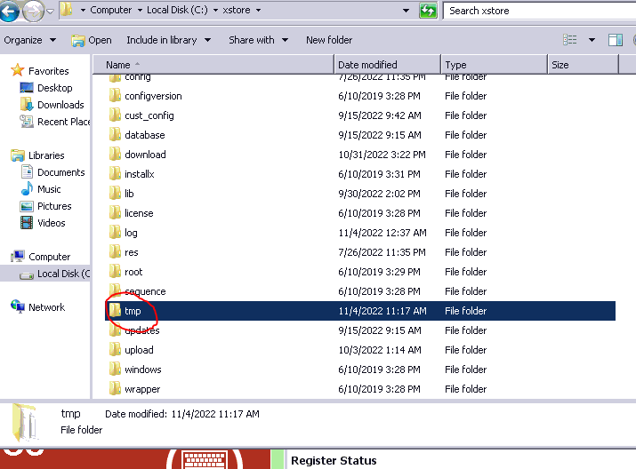

* Navigate to C:\Xstore
* Run Baseconfigure.bat, wait for this to complete fully, **NEVER STOP THIS WHILE RUNNING**
* Run Configure.bat, wait for this to complete fully, **NEVER STOP THIS WHILE RUNNING**
* **NEVER RUN THESE TWO “.bat” FILES AT THE SAME TIME**

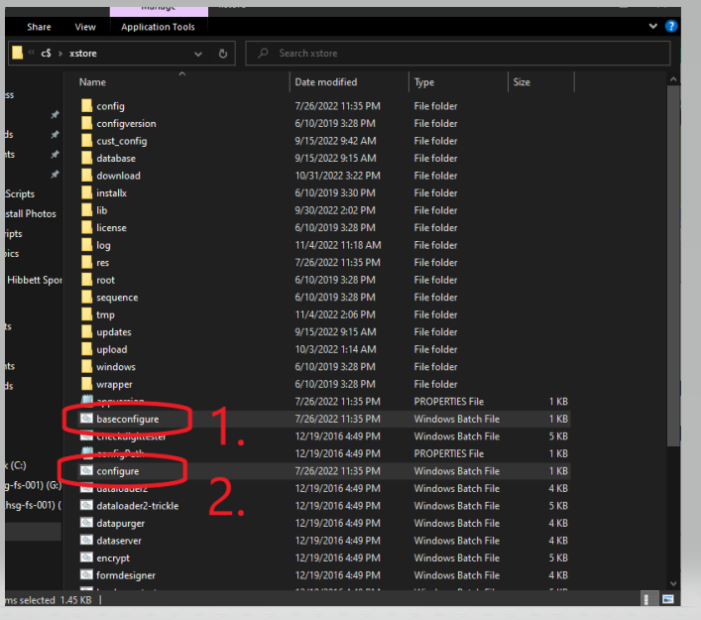

* **RUNNING THESE AT THE SAME TIME, OR STOPPING THEM WHILE RUNNING WILL BREAK THE XSTORE INSTALL AND REQUIRE UPDATING XSTORE TO THE LATEST UPDATE/PATCH**

### Starting XStore and Pairing the Pinpad

* Once we’ve verified all of this, we can go ahead and start xstore back up by navigating back to the green Xenvironment screen, and clicking “Start POS”
* Once the POS starts, log into the back office using the 100 account, or have member of the store personnel log in.

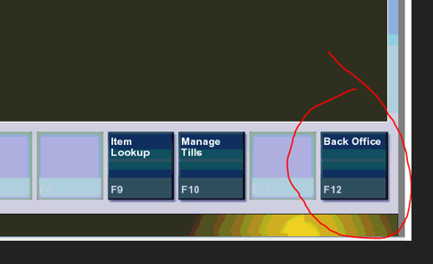

* Navigate to option “E” “Enable or disable devices” from there you will click option F10 “Register Verifone Device” (only need to click this once, if you spam click it, they will have to keep reentering the pairing code).

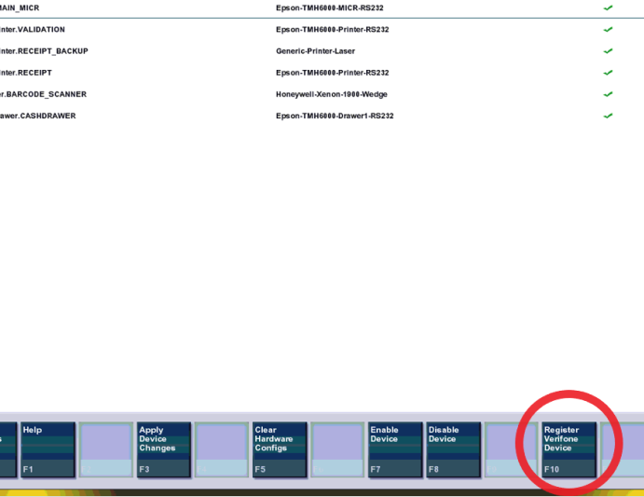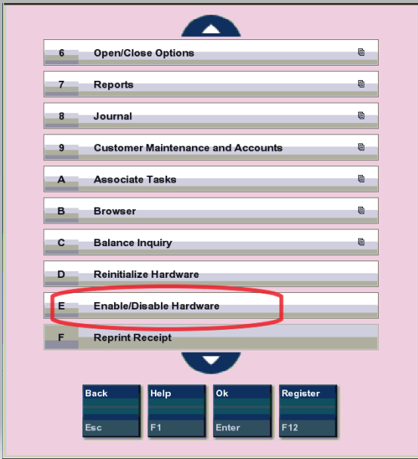

* If everything worked correctly it should ask for a pairing code on the pinpad, this is always “3214” Once this shows “Pin Match” the register pairing process is complete.

### PayWare Connect Additional Setup and Configuration

Once they’ve been installed, we want to check each pinpad in Payware to reset the device keys.

* 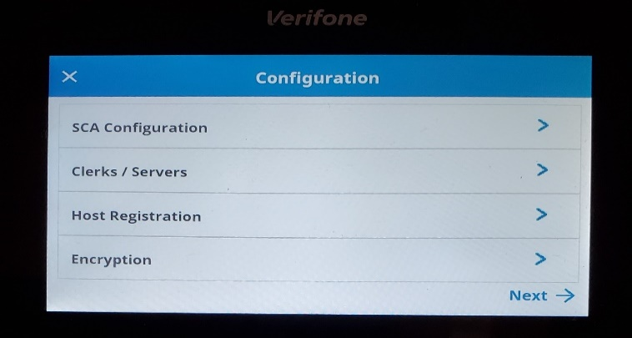 Reset the keys for the pinpad, both in Payware and on the pinpad itself
* **Be aware that when you clear the keys in payware, the pinpad will stop functioning until the keys have been cleared and re-registered on the pinpad**
* ON THE PAYWARE SITE Navigate back to the device master under the ACCOUNT ADMIN TAB
* Search for the Store in the Merchant ID/Name section
* Select the appropriate pinpad
* Click “Reset” to clear the keys in the pinpad, then move on to “Manually Remove Device Key”

### Manually Remove Device Key – Must be done to enable Card Sales

This is how to manually clear the device key and register it again.   
\***Please keep in mind the device key must be reset FIRST in Payware Connect (Previous Step)**

* Hold "**6**" and **Enter** (Green Circle)
* Password is: **166831**
* Select **Host Registration -> Clear Keys -> Yes**

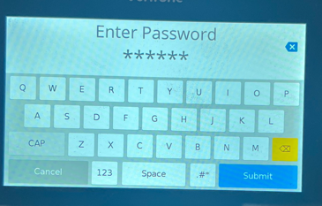

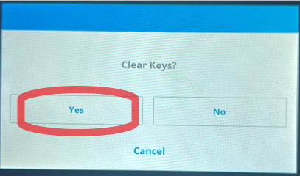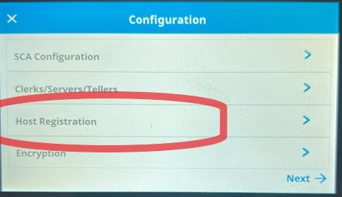

* Select **Encryption** **-> Register**

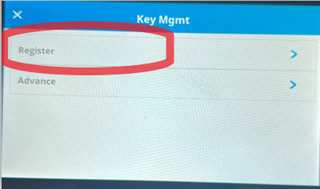

### Complete Test Transaction

* At this point the pinpad is fully paired to the register, but we need to make sure that they can process transactions before we can release the store off the phone.
* Have the Store manager log in to the Register and scan an item that is for sale
* Have them select the “add tenders” button and then select the “Gift card” option
* Press enter and have them swipe a BLANK (UNLOADED) gift card.
* The message on the screen should say “04-INACTIVE ACCOUNT” (If any other message is observed reattempt to clear the device keys and try the sale again. If the issue persists reach out to LVL 2 for advice.

### Check Device Hierarchy in VHQ

* Once all the above has been done, you will need to check the hierarchy path in VHQ and verify that the new pinpads are in the correct Hierarchy.
* To do so you need to first locate the specific pinpad in VHQ, this can be done by clicking on “Device Search”
* From there you can click the dropdown under “Select Attributes” and select “Serial #”, then in the next dropdown select “Contains”
* Next input the serial number into the “Control Value” box (It may work better to input the last few numbers of the serial number here rather than the whole thing, and then skim through to find the correct one, as the search feature here is not always great)
* Click the plus sign, then scroll down and click “Apply Filter”
* When looking at the pinpads found by this search, verify that the Hierarchy path for the pinpad shows “POINTNA-HIBBETT>>CG(Or HB)>>Store Number
* If not, you can click the check box to the left of the serial number, then select “Edit Hierarchy”
* From there you can navigate to the exact hierarchy path for that store and apply the new Hierarchy

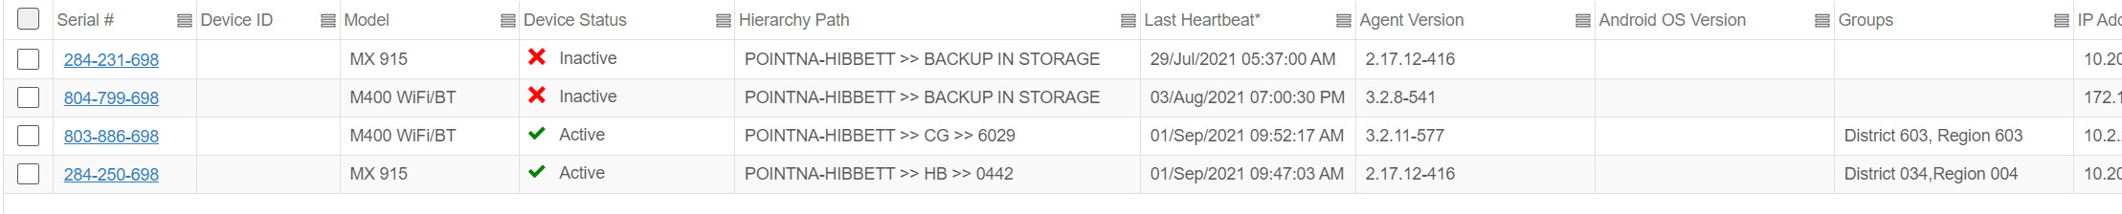

### Verify Downloads Processed In VHQ

* Once in the correct Hierarchy, click into the pinpad in VHQ
* From there you’re going to click ”Details” and then hover over software status and click on “Packages”

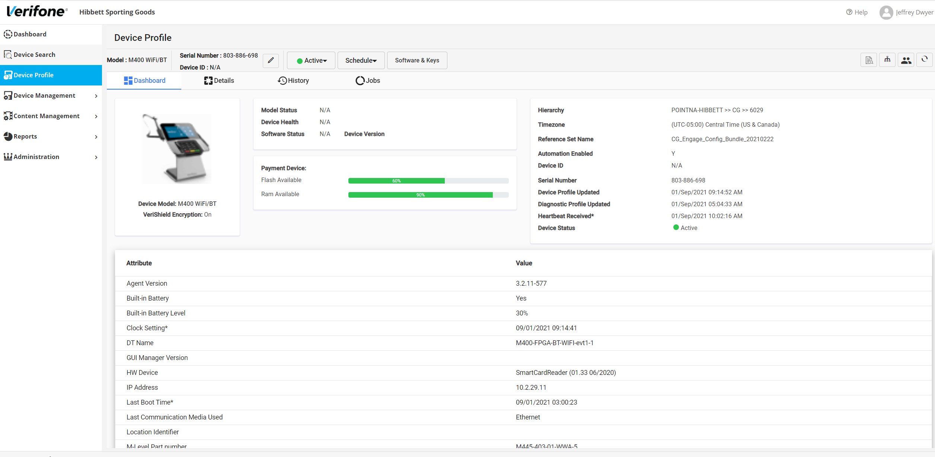

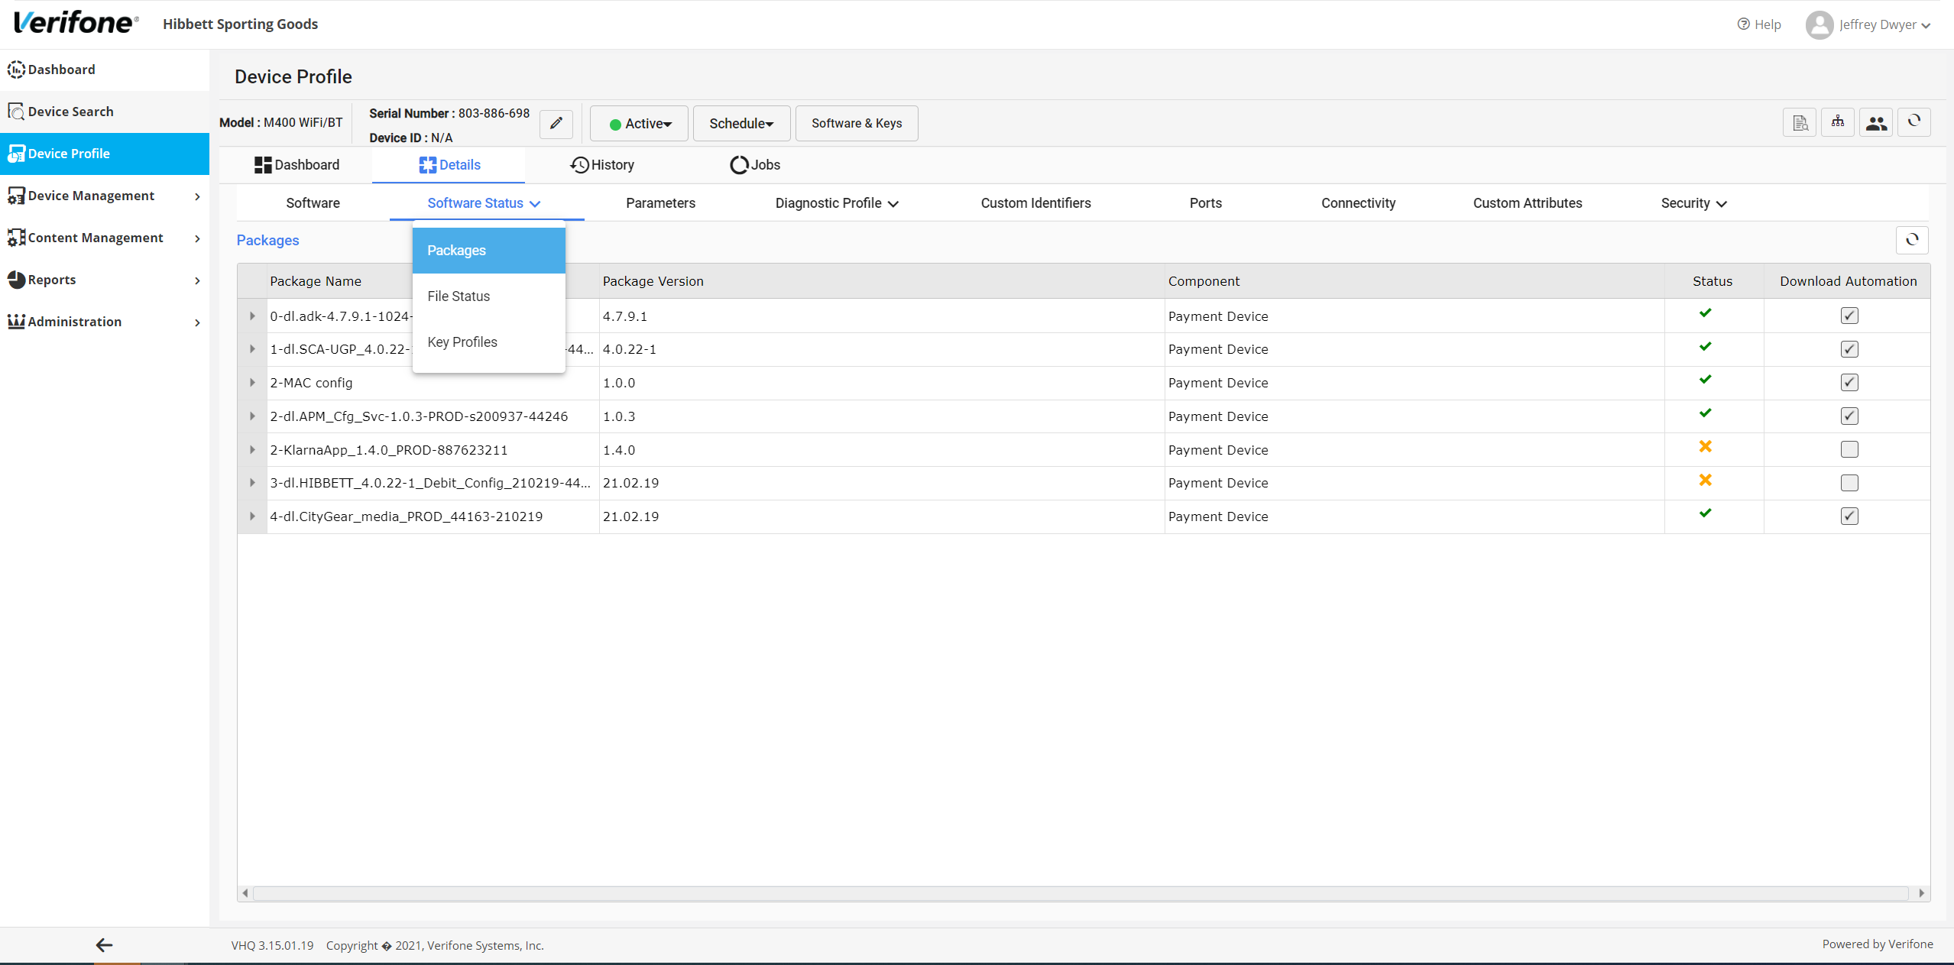

* From there we want to verify that all the packages shown there show green check marks, except for the two that have X’s in the below photo
* Once all the others have green checks, uncheck the check marks beside the two that have the red x’s (2-KlarnaApp_1.4.0_PROD-887623211) and (3-dl.HIBBETT_4.0.22-1_Debit_Config_210219-44261)
* If after around an hour these are still showing x’s, you will need to check the “Jobs” tab to see if any of the downloads/installs failed
* If there are any failed jobs in the “Jobs” tab under “Download” you should be able to schedule a new push by clicking on “Schedule” near the top of the page and selecting “Downloads” From there you can manually schedule downloads by Reference Set. These Reference Sets contain the entire software stack needed to update the pinpads and are brand specific (HB-Hibbett and CG-City Gear), you do want to be sure you push the correct one as this affects the branding on the pinpads.

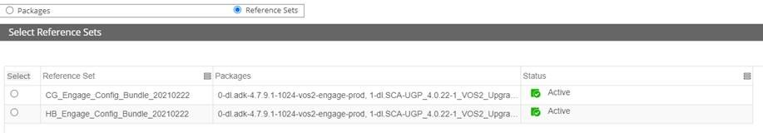

### Request Heartbeat

This screen gives the option to send a heartbeat check to the VHQ server. (This is not often necessary but can be a useful troubleshooting step if you want to verify the pinpad is communicating with VHQ, or if you want to try to prompt it to attempt pulling its downloads earlier)

* After entering in the Supervisor login go to the following:

***Administration -> VHQ Tools -> Request HB***

* 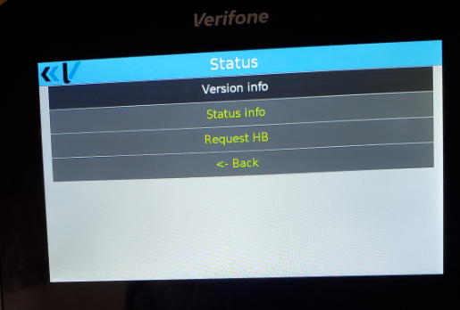Select ***Status Info*** for the heartbeat results.

### Cleanup Work

These are all tasks to be done after the install has completed successfully for a store, these do need to be done, as they can affect the operations of other departments.

#### Mark old Pinpads Inactive/Remove from VHQ Hierarchy

* In VHQ, you can search devices by store Hierarchy
* To do this, instead of inputting an attribute, you will navigate using the folders in the upper portion of the search window while in List View
* Navigate to POINTNA-HIBBET>>CG(City Gear) or HB(Hibbett)>>Store Number
* Click the “+” next to the store number to add the filter, then scroll down and click “Add Filter” to show all pinpads with that specific Hierarchy (you can show multiple hierarchies at once if you’d prefer to pull up all stores you are doing for the day at once)
* From there you can see both the new M400 and the old M400 that is being replaced.
* Once the pinpad is installed and tested, we will want to click the check box by the old M400 for that store and mark it as **Inactive-No Sub Status-**
* Then click “Edit Hierarchy” and move it to POINTNA-HIBBETT>>BACKUP IN STORAGE

#### Removing Old Pinpads in Payware

Once the pinpad has been installed and tested, we need to remove the old MX915 pinpads from the store’s merchant account in Payware Connect.

* Log into Payware Connect
* Hover over **"Account Admin"** and choose **"Merchant Console Access"**
* Search for the store number that is experiencing the issue
* Select the store from the list that populates, then choose to login to access that store's merchant account
* Once in the correct merchant, hover over "Account Admin" again, then click "Device Master"
* In device master, locate the old M400 pinpads, click each one and then choose “Delete”
* **Only remove pinpads that are no longer being used, as this will stop them from functioning in store**